

DYNAMICS TMS

Objectives:
- RATE SHOP Page

Introduction:
Dynamics TMS Rate Shopping Page is where users can rate shop and access quotes in a single screen. Depending on your configuration, users can also dispatch orders from the same screen. Please check with support on your configuration before dispatching.

Rate Shop

Current Loads

The rate shop system will rate shipments using all of your tariffs and carrier api connectivity in a single solution.
To rate shop, go to the Actions tab and select Clear All, this will remove any data left from a previous request. The system will remember your last entry and therefore, all you need to do is just change the Load date/Req delivery date, destination information, and metrics rather than starting over.
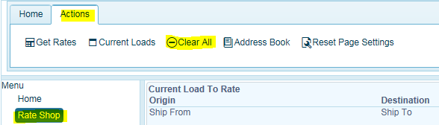
Click on Current Loads to enter in your rate shopping criteria.
Must enter in Ship Date and Required Delivery Date. The system does not accept blank data fields. The information is used to execute the rating function and not an actual delivery date.
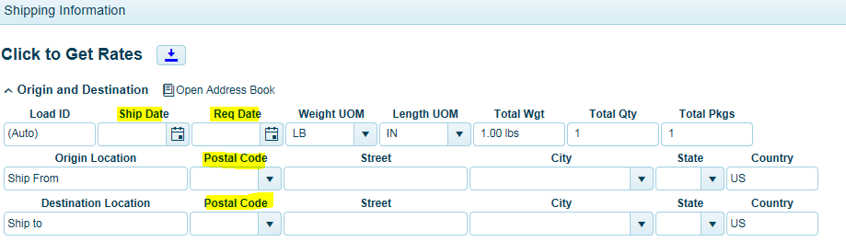
NOTE: In order to rate shop your carriers using the TMS tariff system, you must include the origin location set up in TMS. You can find this by clicking on the Address Book for any stored origin/destination locations. Be sure that your location postal code does not have a hyphenated postal code extension. They will not return results.
Click on Open Address Book, find the origin and select the row, click Set Origin. To find the Destination address, select the row, and click Set Destination. Or just enter in destination postal code on the rate shopping screen. If you just put in the origin postal code, the system will not include tariffs that reside in the TMS database (non-API carriers)
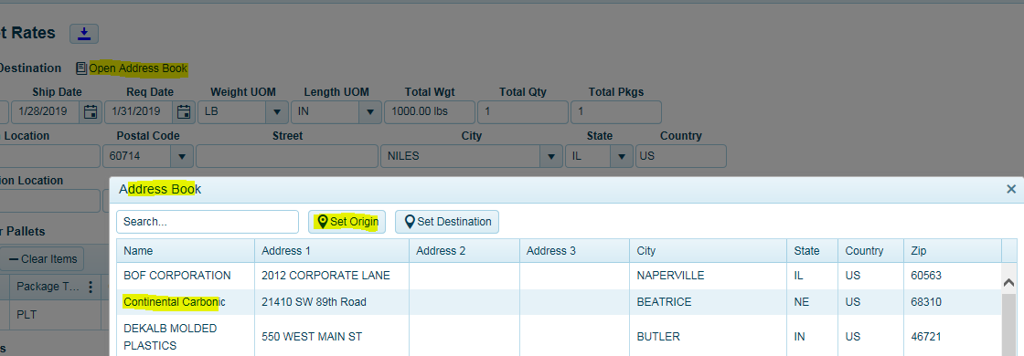
Next enter in your shipment metrics. Click on Add Item to fill in the required information for your rate request.
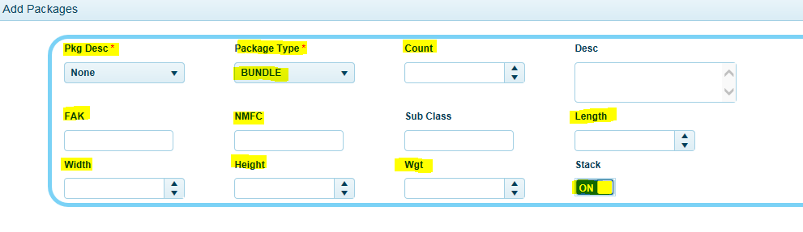
Pkg Desc if configured = will automatically insert FAK Class and Product Description.
Package Type = should be PLT for pallets.
Count = the number of pallets.
Insert NMFC if required. Will auto populate if part of the Pkg Desc configuration.
Insert dimensions.
If you want to add an accessorial, use the drop-down list to select your accessorial and click on Add Accessorial. The system will return the accessorial charge in the rate estimate for api carriers only.
Then click save to save your entry.
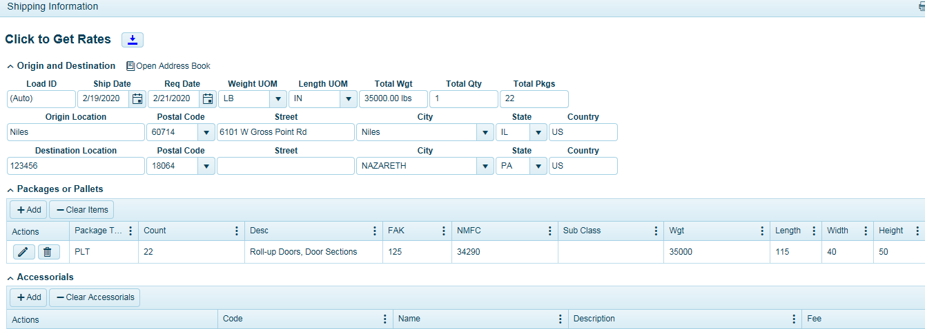
Click Get Rates button.
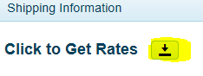
The system will return your carrier rates, quote number (if returned-not always applicable), transit times, and interline notification. Some carriers may return $0 -zero cost. This could be for a variety of reasons such as connectivity issues with API, do not service destination etc. In the Errs column, you will see a number. If greater than zero, the system returned an error message. This message can be reviewed by expanding the black arrow for that carrier and clicking on the error tab.
To eliminate from seeing zero cost quotes, use your filters to apply cost range greater than $1 - $5,000.
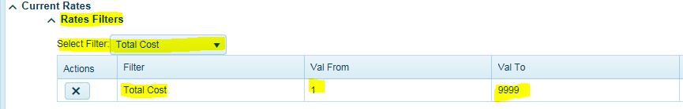
Note: Some but not all implementations will make use of the Book IT button (dispatching to carrier). You should ask support if your configuration will be using this process. If your configuration is not utilizing the Book IT function and the Book IT button is clicked upon, the system will display the dispatching screen for user to complete. If accidentally clicked upon, just close the screen and nothing will be dispatched.
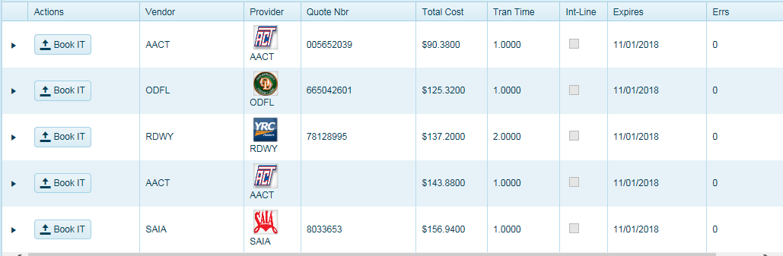
Users can use the filter options to configure the columns they wish to display. Use the drop-down list and check on or off to display or remove a column. Click Reset Page Settings to return to default settings.
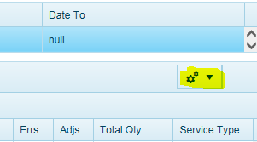

Click Clear All to start a new rate shop or use Current Loads to keep stored information.
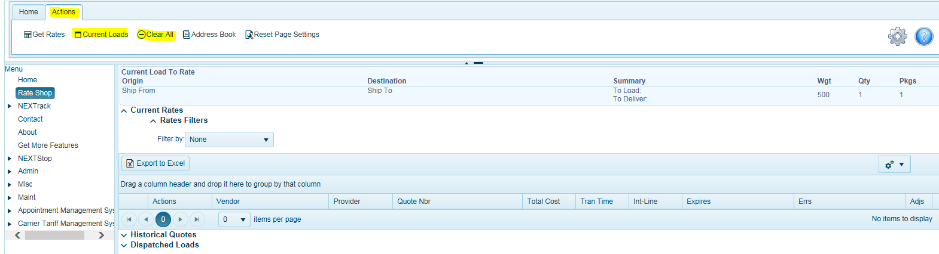

Historical Quotes
Quotes are stored here for reference. Click and expand the black arrow to see quoted rates. Click the Book It button to dispatch the load with carrier. Note, this is not for all configurations. Check with support to see if your configuration supports this feature.

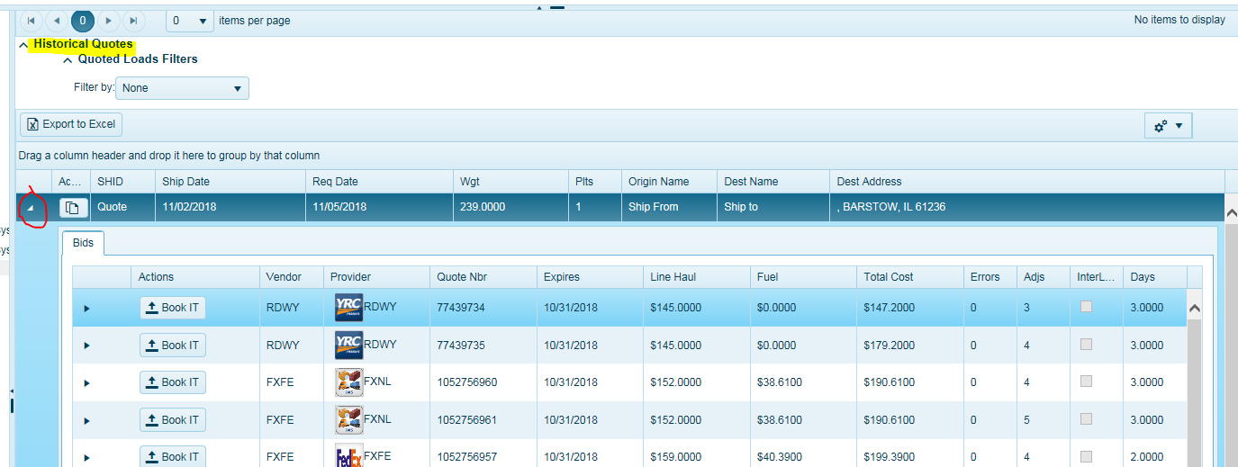

Dispatched
Here you will see a list of all loads that have dispatched. Click the BOL button to print the BOL form.
